**Pharma Sales Dash Board**

Sales task(1 to4)

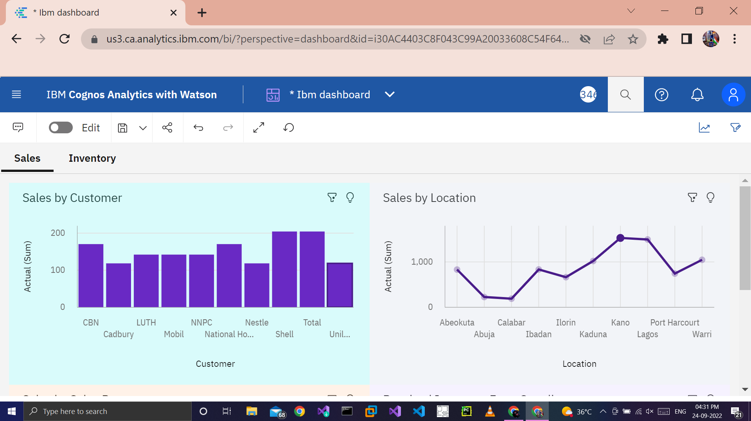

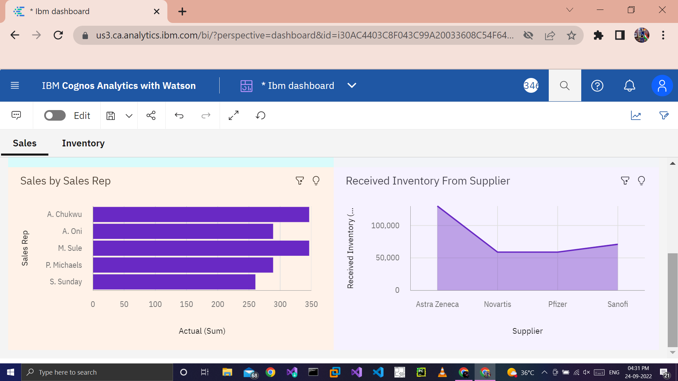

https://us3.ca.analytics.ibm.com/bi/?perspective=dashboard&pathRef=.my_folders%2FIbm%2Bdashboard&action=view&mode=dashboard&subView=model000001836e357d6a_00000000

Inventory (Task 5to 8):-

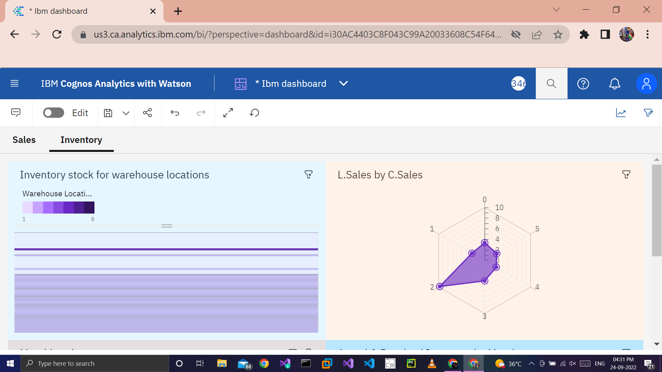

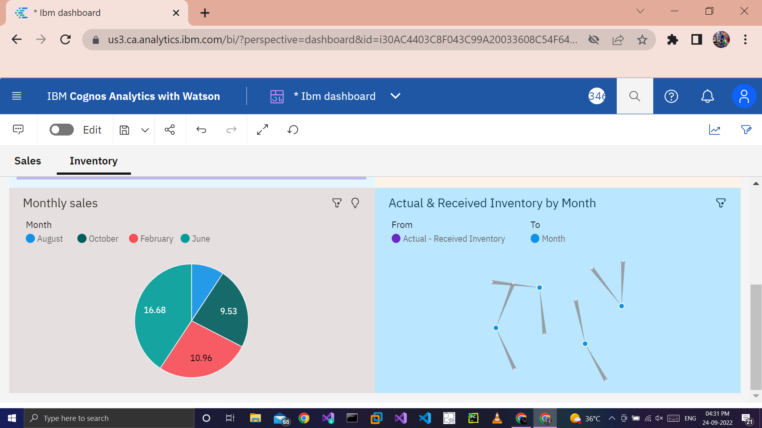

https://us3.ca.analytics.ibm.com/bi/?perspective=dashboard&pathRef=.my_folders%2FIbm%2Bdashboard&action=view&mode=dashboard&subView=model000001836e3b251e_00000000